 | ELPIS IT SOLUTION PRIVATE LIMITED | Department: | Software Development
 | QUALITY MANAGEMENT SYSTEM | Doc. Ref: | EITSPL-QR-SW-01
Project Requirement – Clarification record - VAS |  | Doc. revision: | 0.0
 |  | Issue Date: | 03.04.2026

VAS 2.0
Version: 1.0.27
Redmine: Feature #3423 : Alert Notification
VERSION | REVISION DATE | DESCRIPTION OF CHANGE | AUTHOR  (Name & Title) | Review and Approval  (Name & Title) | Review and Approval Date
0.0 | 27th October 2025 | Initial Version | Mr. Jiban Kumar Munda  (Development Team) | Mr. Sudhakar Chakravarthi  (Internal Product Owner) | 27th October 2025
Analysis Report

Objective: -

This document highlights the behavior and functionality of the Vibration Analyzer (VAS) as far as Redmine #3423 is concerned.

VAS Behavior: -
- By default, the app will have some preset threshold data. The user can change these values later.
- When the app is online (connected to the device and receiving data) and the Time Series and Spectrogram graph (FFT) data falls under the threshold range, the user will receive an alert.
- Each channel can have a different configurable threshold value for the Time Series and Spectrogram graph (FFT).
- To view or change the settings, open the Settings view from the menu, as shown in the image below.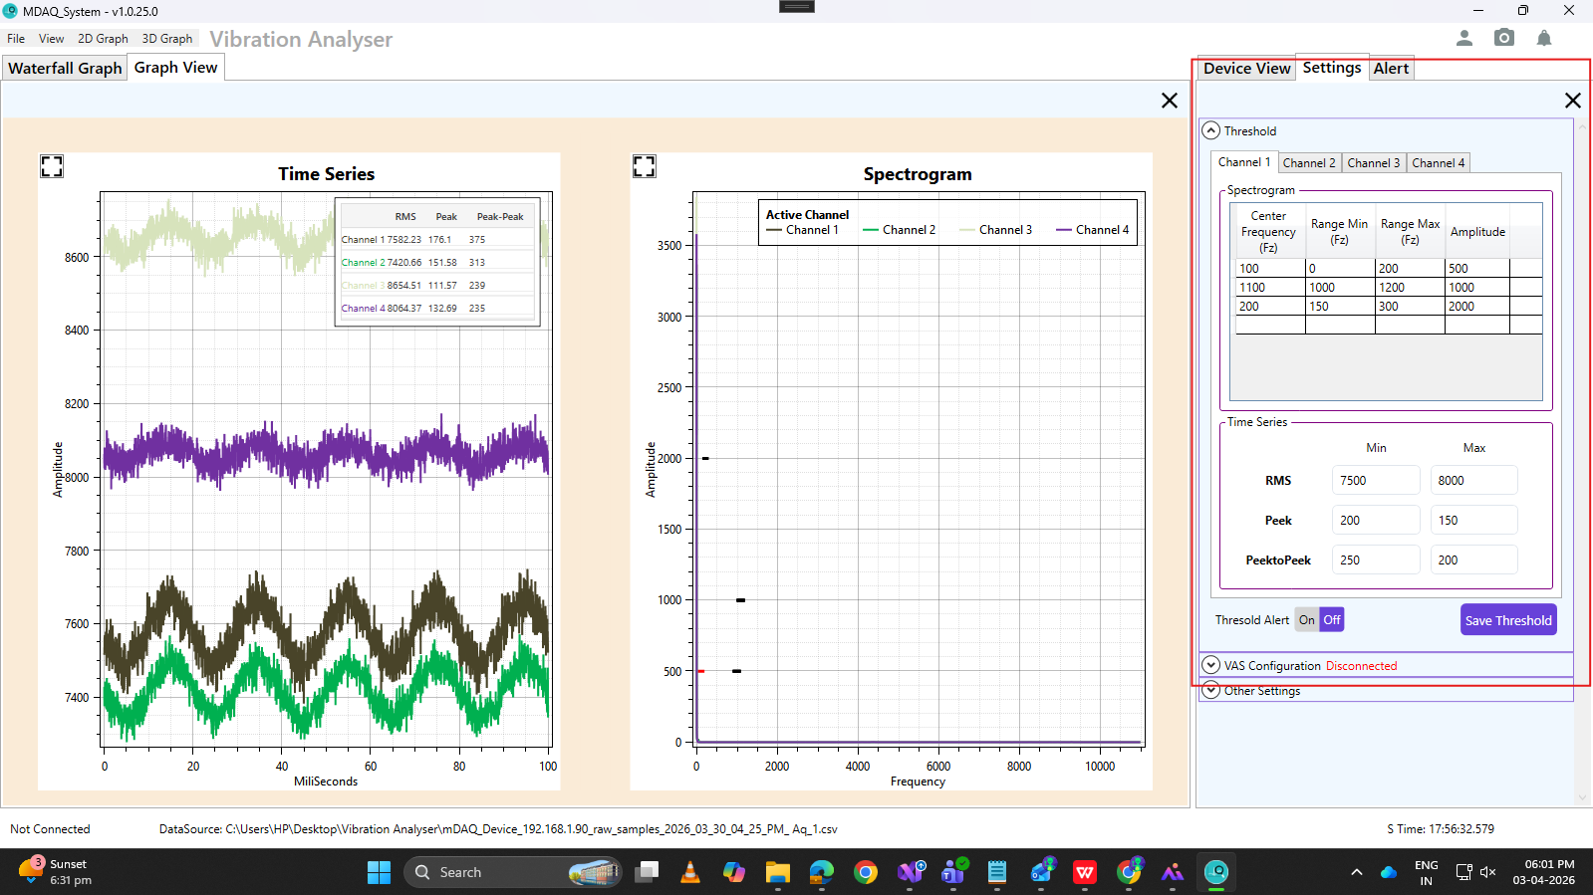
- For Spectrogram or FFT threshold parameters (Frequency (X), Amplitude (Y)), the following are defined:
- Center Frequency(Hz) : a single value that makes it easier to represent the min-to-max range.
- Range Min(Hz)
- Range Max(Hz)
- Amplitude
- For TimeSeries threshold parameters, the following are defined:
- Min RMS
- Max RMS
- Min Peek
- Max Peek
- Min PeekToPeek
- Max PeekToPeak
- These threshold data will be saved in a file named GraphThresholdData.json, located at C:\Users\HP\AppData\Roaming\MDaq_System.
- When the current acquisition's time series data and FFT data fall within their respective threshold ranges, and the respective graph is present, we will show the observed data in the Alert view.
- In FFT, there can be multiple observed data points (highest points) within a single channel's FFT threshold range. For example, from Min (10, 100) to Max (100, 100): suppose the first peak point is (30, 400), then the graph's Y-axis falls to 150 and rises again to point (60, 300). In this case, points (30, 400) and (60, 300) are observed values for the Center Frequency (50, 100) of Channel 1.
- For example, in TimeSeries, suppose the RMS range is (7500, 8000) and Channel 1's RMS value is 7582. The user will then see this observed data in the Alert view. For the Spectrogram, if the center frequency is 100 and the amplitude threshold is 500, then for this acquisition, the observed value is (2.69, 3389.46), as shown in the image below.
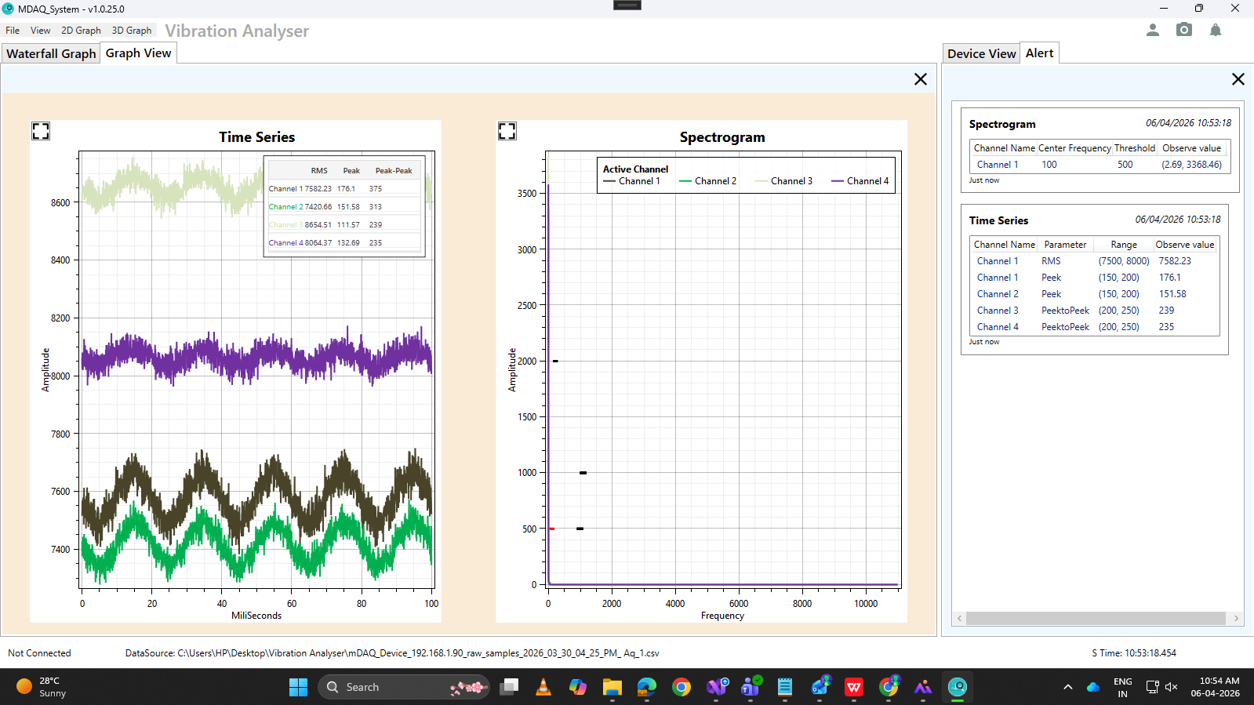

When data is meet with threshold range and alert view is not open then on top right corner Alert button will indicate red dot under it . So user can navigate to see threshold value by clicking this Alert button.

