 | ELPIS IT SOLUTION PRIVATE LIMITED | Department: | Software Development
 | QUALITY MANAGEMENT SYSTEM | Doc. Ref: | EITSPL-QR-SW-01
Project Requirement – Clarification record - VAS |  | Doc. revision: | 0.0
 |  | Issue Date: | 30.03.2026

VAS 2.0
Version: 1.0.27
Redmine: Feature #3411 : Peak and Peak-Peak in an Analysis window
VERSION | REVISION DATE | DESCRIPTION OF CHANGE | AUTHOR  (Name & Title) | Review and Approval  (Name & Title) | Review and Approval Date
0.0 | 27th October 2025 | Initial Version | Mr. Jiban Kumar Munda  (Development Team) | Mr. Sudhakar Chakravarthi  (Internal Product Owner) | 27th October 2025
Analysis Report

Objective: -

This document highlights the behavior and functionality of the Vibration Analyzer (VAS) as far as Redmine #3411 is concerned.

VAS Behavior: -
For the Peak and Peak-to-Peak feature, the data will be shown in a time series graph along with RMS data in a data grid, as shown in the image below.

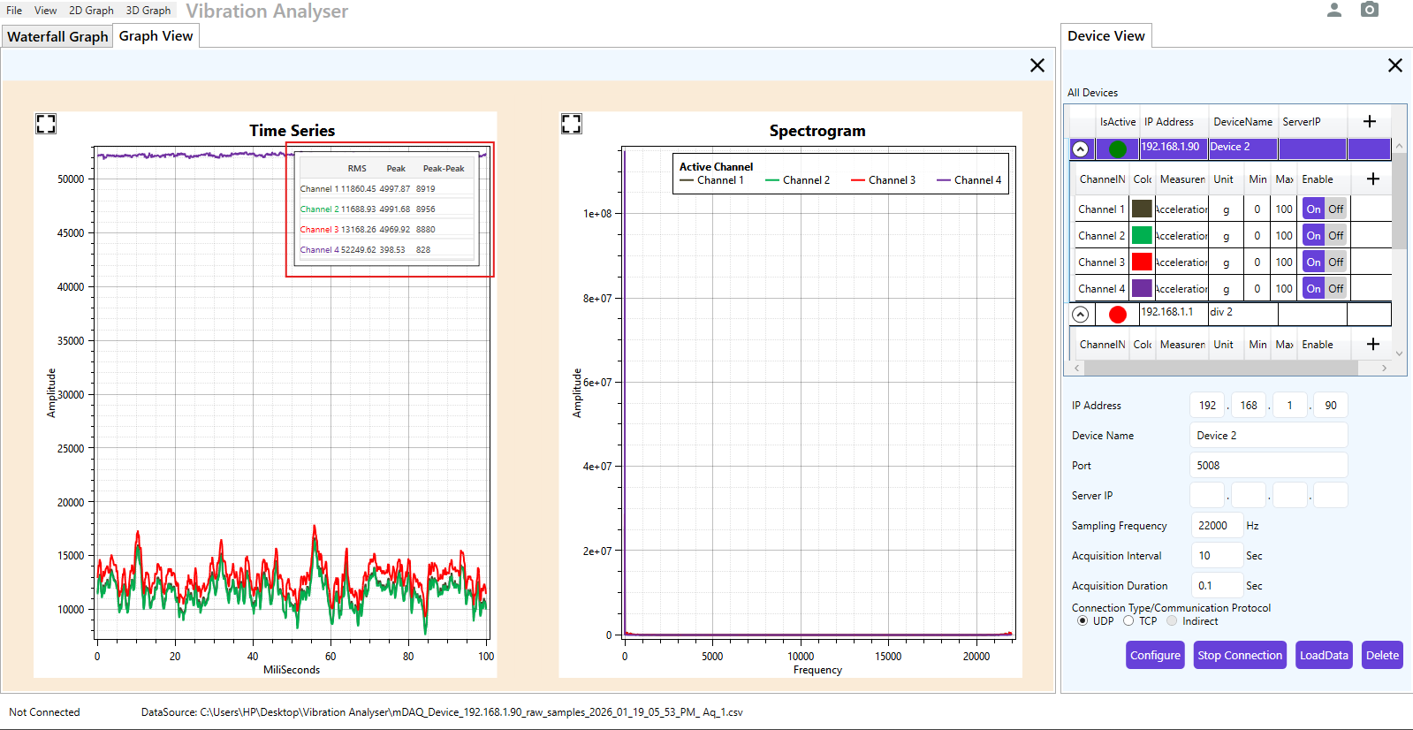
For the calculation of Peak and Peak-to-Peak values, we used the following calculation:
For example, let's look at Channel 1 data:
- minY = 7865
- maxY = 16784
- listCount = 2200
- avgY = Sum of Y in list / listCount = 11786.13
Peak = max of (minY – avgY) and (maxY – avgY)
= –3921.13 and 4994.87

So, the peak is 4994.87.
Peak-to-Peak = maxY – minY = 8919

