 | ELPIS IT SOLUTION PRIVATE LIMITED | Department: | Software Development
 | QUALITY MANAGEMENT SYSTEM | Doc. Ref: | EITSPL-QR-SW-01
Project Requirement – Clarification record - VAS |  | Doc. revision: | 0.0
 |  | Issue Date: | 30.03.2026

VAS 2.0
Version: 1.0.27
Redmine: Feature #3433 : User Credentials and Functions
VERSION | REVISION DATE | DESCRIPTION OF CHANGE | AUTHOR  (Name & Title) | Review and Approval  (Name & Title) | Review and Approval Date
0.0 | 27th October 2025 | Initial Version | Mr. Jiban Kumar Munda  (Development Team) | Mr. Sudhakar Chakravarthi  (Internal Product Owner) | 27th October 2025
Analysis Report

Objective: -

This document highlights the behavior and functionality of the Vibration Analyzer (VAS) as far as Redmine #3433 is concerned.

VAS Behavior: -
When a user installs our MDAQ_System app for the first time, they will see a login screen as shown below.
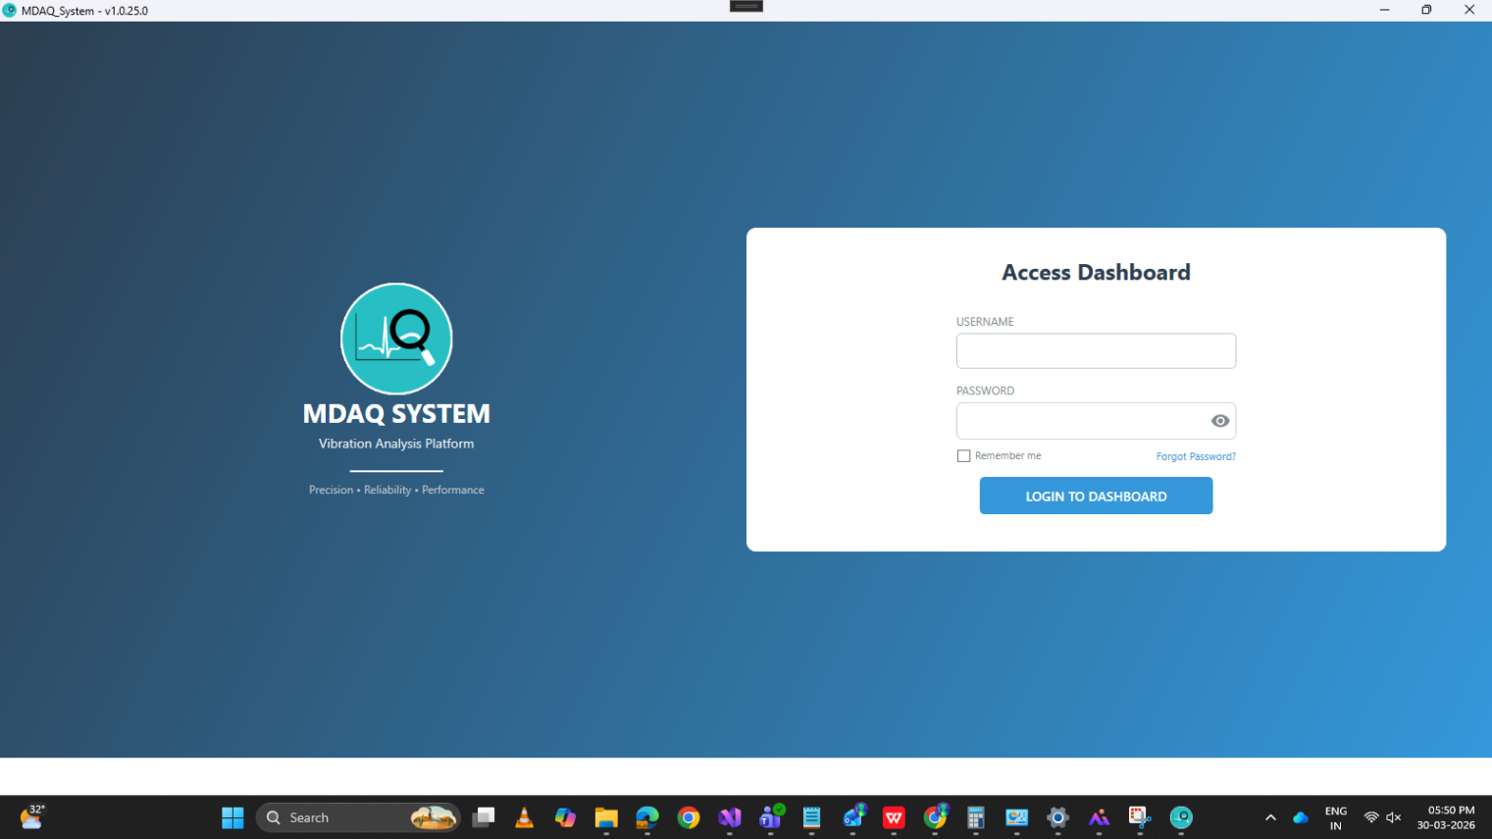
The user will enter the default Admin credentials provided by Elpis and log in to the dashboard.
On the dashboard, a profile menu button is located at the top-right corner of the app. When the user clicks it, a popup appears.
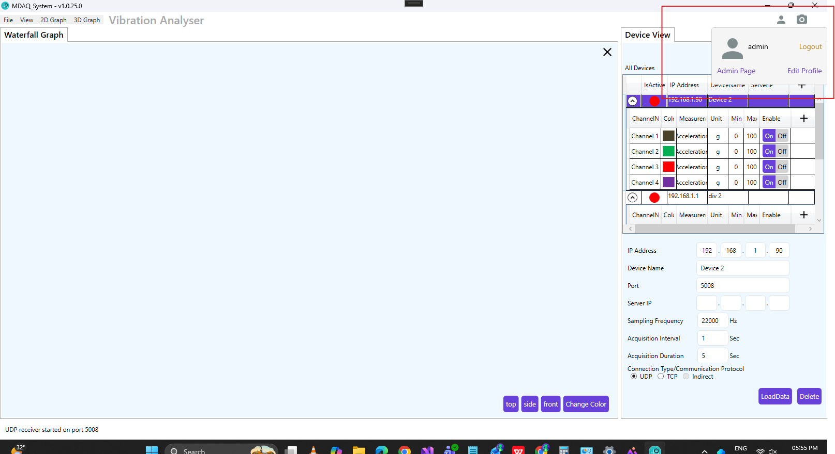
In this popup view, there are three buttons:

- Logout button
When the user clicks the logout button, the login window appears, and the user needs to re-enter credentials to log in.

- Edit profile button
When the user clicks this button, the Edit Profile window appears, allowing the user to change their username and password.
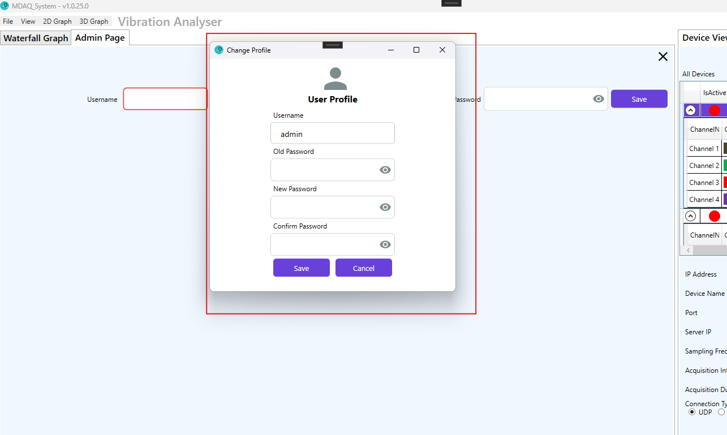
- Admin page (visible only to Admin users)
When the user clicks this button, the Admin page view opens.
Here, the Admin can add other users or create other admins, view all users, and delete normal users by clicking the delete button. (Admins themselves cannot be deleted here.)
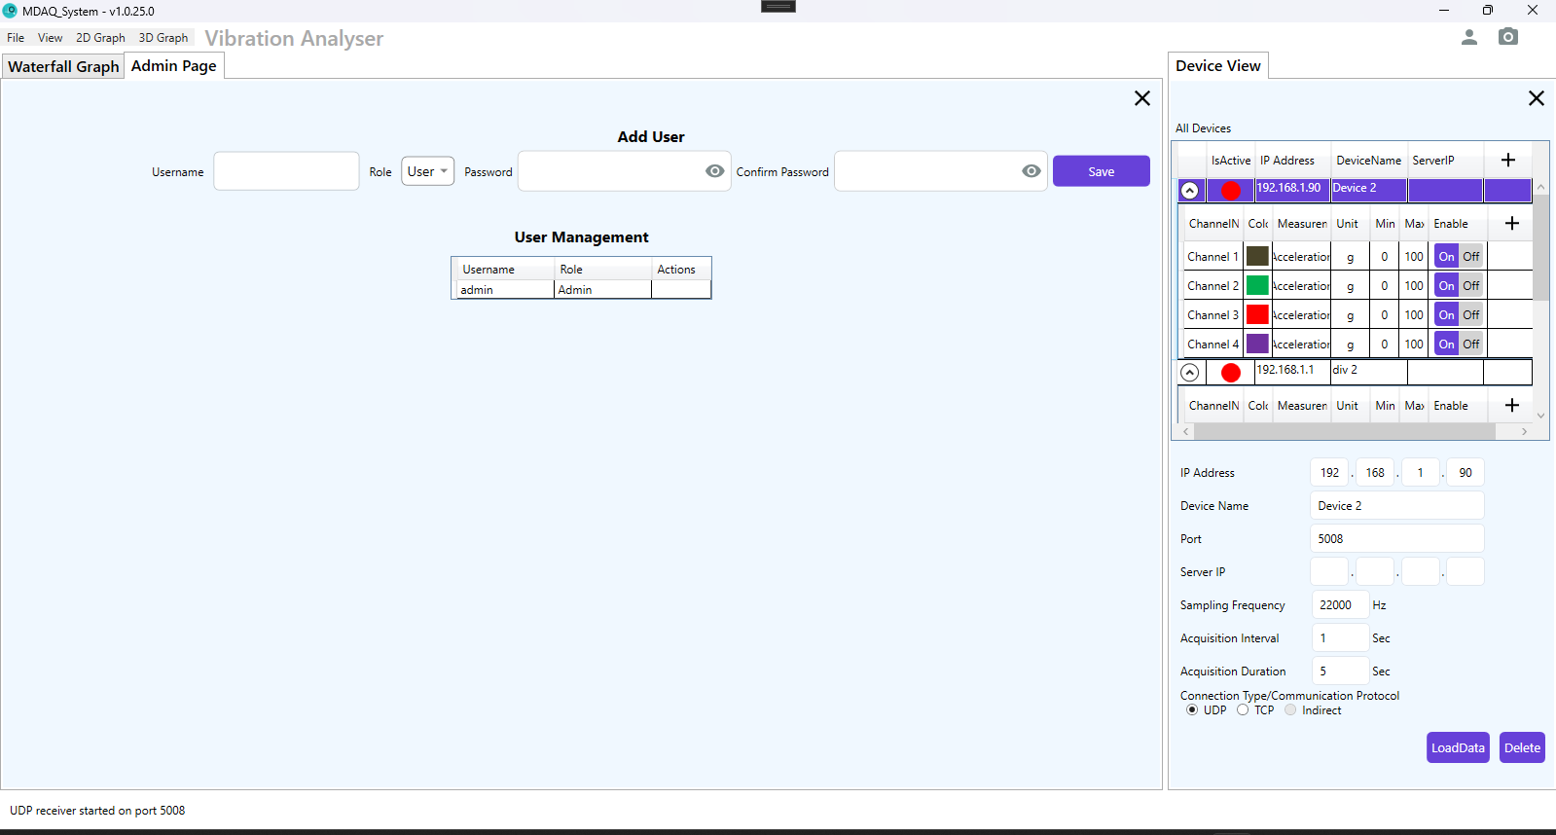
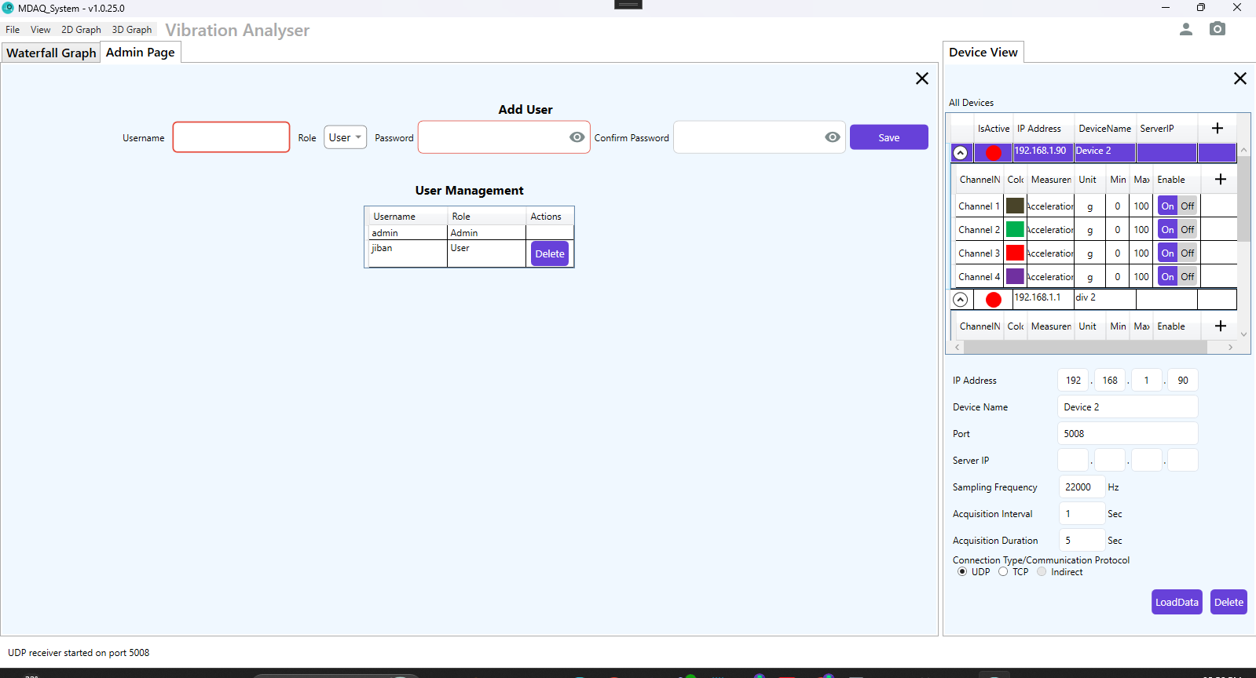

When the user is a normal user, they cannot add devices or channels in the Device view, nor can they see additional settings in the Settings view.
